New Desire Stateside and Honduras
231 Gordon Road
Cedartown, Ga 30125
Venmo: @NewDesire-1990
PayPal: PayPal.Me/newdesire
September 2021

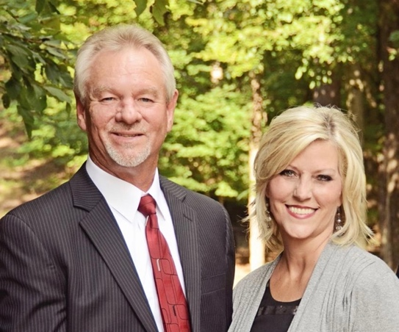

A Message from Dan and Brenda
Dan and I are so very thankful for everyone who has given toward the purchase of the second utility truck and for those who have contributed for us to go to feeding four days a week. Our hearts are overwhelmed at God’s provision and your faith to give. We Love You All and We Just Love Jesus!

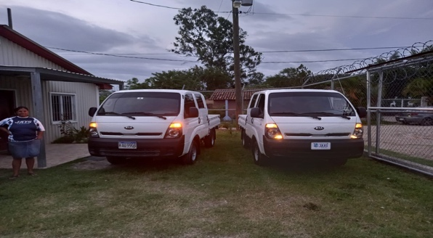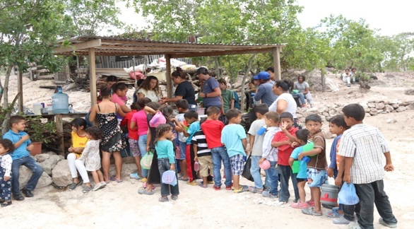

The Happenings in Honduras

In July, we had a team from Reeds Chapel Baptist Church spend a week in Honduras and what a mission trip it was. God used this team in a mighty way and was so effective for God. The team had a building project at Mrs. Ana’s home to rebuild a roof and pour concrete in the kitchen area of her home. The team was able to build the roof, pour the concrete and add a sidewalk for the family all in 2 days. The family was ecstatic and so humbled for the blessing they received. The team had a Children’s Day and Youth Day where the youth lead the services for the events and prepared crafts and activities for them. The theme for the whole trip was “The Power of the Tongue.” Nicki led a Women’s Conference for the ladies on Thursday afternoon. She presented a lesson about how our tongues should reflect Jesus and how the power of our words can help us or hurt us. The ladies were presented with a craft after the teaching. It was an effective time in the Lord. Pastor Jeff preached Sunday morning at the river and took part with Pastor Raul in baptizing 16 people. That was such an amazing and beautiful sight to see all the people in attendance gather in the river to have service. There were over 90 plus in attendance in the river for church. He also preached at The Church on the Mountain Sunday night. The kids fellowshipped each night with the Hondurans as they played soccer at the mission house, sang in the church, or played UNO. They all just loved being together! Gaby, our Missions Director, had the team to participate in a Honduran Day where we made tortillas and washed our clothes in the pila and hung them to dry on the clothesline. We love this idea to allow teams to experience the Honduran way of life. As the team ministered in Honduras, Dan and Brenda were on a 10-day tour in Mississippi doing missions presentations, women conference, men conference, and revival. God honored these two teams in two different places to spread the Gospel of Jesus Christ, for their obedience, sacrifice, and their effectiveness for God.

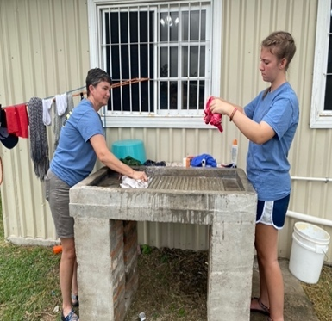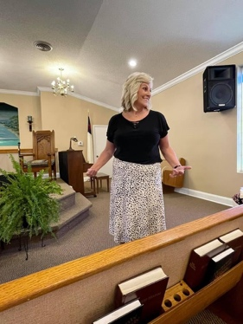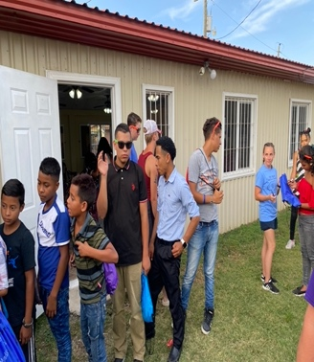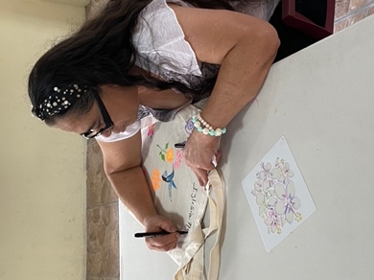

We Just Love Jesus!
Mission Trip Photos

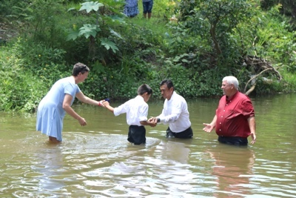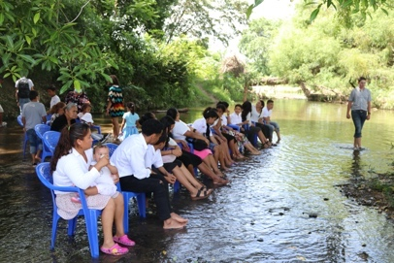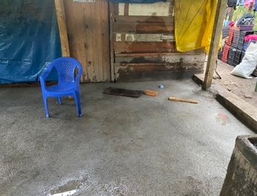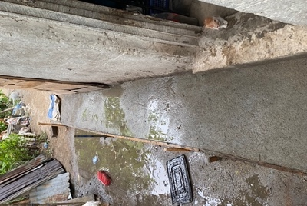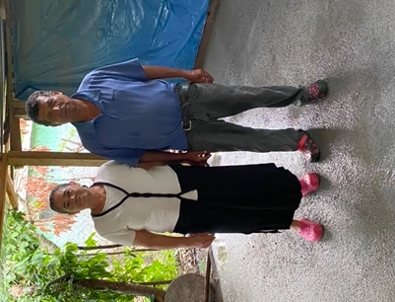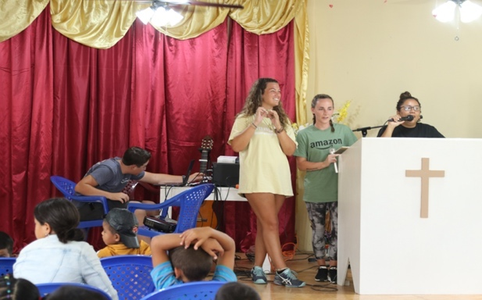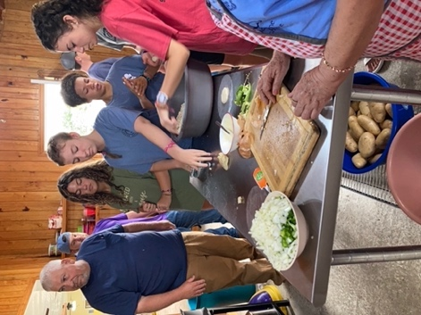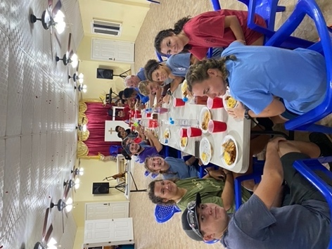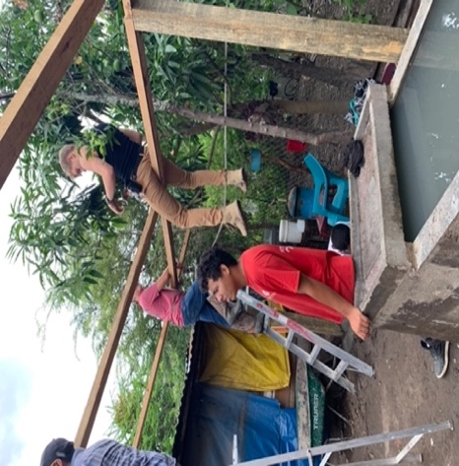
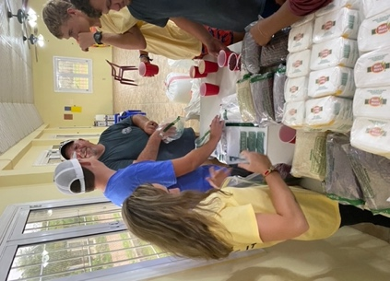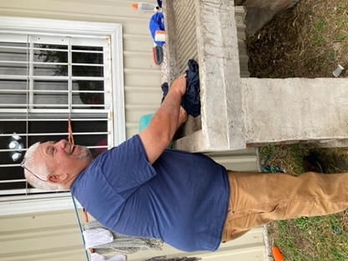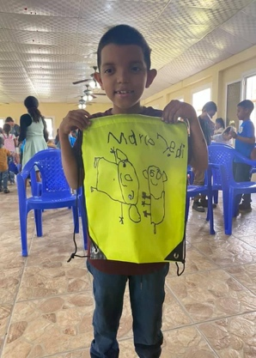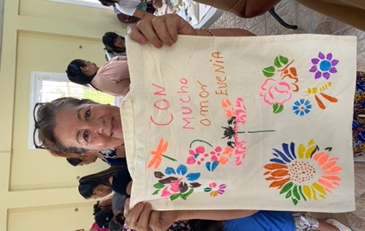
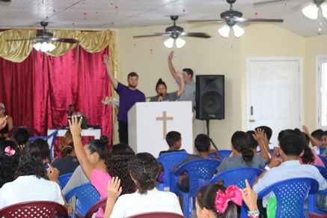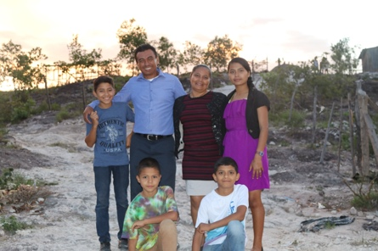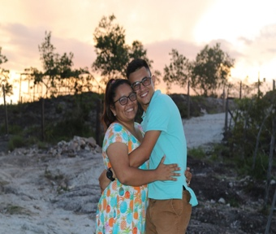

Sewing for Jesus
The students in the sewing ministry under the leadership of Mrs. Ana are growing leaps and bounds with their ability to sew. They have learned how to make shirts, skirts, and dresses. It is a huge blessing to see the excitement on the faces of the girls and young women as they are learning a trade that will help provide for their families and become a job for them. We are so blessed to have Mrs. Ana and her willingness to use her talent to teach these girls and give them an opportunity to make a difference in their lives. Check out the clothing the girls made and had on display for the team to see in July.

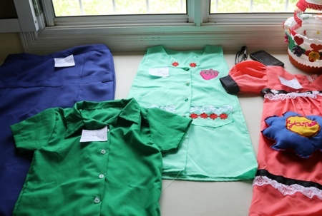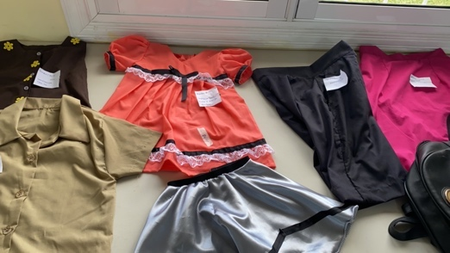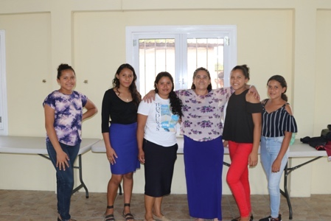

New Desire Stateside Events

New Desire is back on the road, and we couldn’t be more excited to be back doing what we love and what God has called us to do! Covid had everything in slow motion as far as going into churches speaking and preaching. We are honored to be back in God’s House sharing the Gospel of Jesus Christ. If you or your church would like to book New Desire for a Women’s Conference, Bible Study, Virtual Bible Study, Revival, or Marriage Retreat, please contact Brenda @ 770-324-0005 or Nicki @ 706-773-1935. Be sure to leave a message. We would love to come and worship with you! Below you will find our upcoming events.

- September 18-22 – Women’s Conference and Revival – The Bible Church- Darlington, SC
- September 25- Women’s Conference Higher Ground Baptist Church @ 10:30 cst – Gadsden, Ala
- October 2 – 3 – Women’s Conference and Brenda Sings – Westside Baptist – Newnan, Ga
- October 15-17 – New Desire Marriage Retreat – Gatlinburg, TN - $550 per couple (we still have room for 10 couples) Payments can be made up until day of retreat.
- November 20 – 28 – Honduras Mission Trip (Top and sides for Sunday School Building)

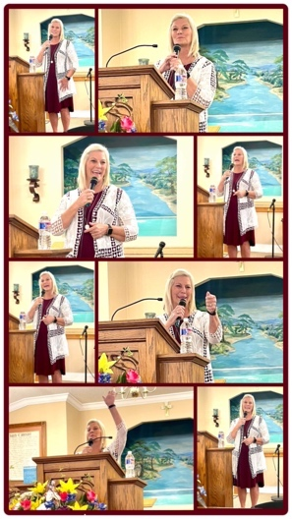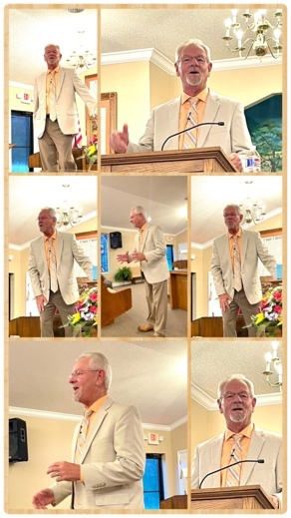

How Can You Help with Our Needs?

More Expensive Needs:
Building up our General Fund to be able to keep the entire mission property and possessions up and running. The general fund is where we put our money for the feeding kitchen, repairs, annual registrations on all vehicles, fuel for feeding kitchen and mission house. The general fund also pays our pastor, mission director, and grounds keeper monthly. The general fund is our lifeline to keep everything operating. Please pray with us about this account. The church doesn’t take in enough tithes to help with these necessities.

We need:
- Constant Prayer
- Monthly sponsors toward the general fund.
- Sponsorships for our Educating Ambassadors for Christ Educational Program. $150 per child will provide school for a year
- Sponsors for our Feeding Program each week. It costs $150 per week to feed our elders and school kids in our feeding program and now we are providing for two churches. We are now in need of an extra $500 per month to feed 4 meals weekly in La Ermita and at the Mountain Church
- Approximately $6000 to put top and sides on the Sunday School Building
- We will be providing shoes for Christmas again to the people of both churches of New Desire Honduras. We will provide over 200 pair of shoes for Christmas. Please be in prayer about helping with this need.

Teams Welcome
It is not too late to book your team to come and help us train, feed, and minister through bible classes, VBS for children, health teams, visit the community, pass out rice and beans while loving on them through the Word of God, prayer, and listening to their hearts. For more information contact New Desire Christian Ministries at 770-324-0005 or www.newdesire.org or on Facebook. You may also call Nicki Freeman (Missions Administrator) at 706-773-1935 or nickifreeman1973@gmail.com. We appreciate all your prayers and support. We could not do everything we do without YOU! We Just Love Jesus!

