New Desire Stateside and Honduras
231 Gordon Road
Cedartown, Ga 30125
Venmo: @NewDesire-1990
PayPal: PayPal.Me/newdesire

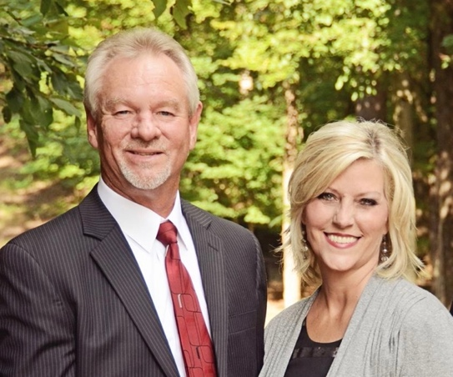

New Desire Honduras
Colossians 1:9-12 says, “For this reason we also, since the day we heard it, do not cease to pray for you, and to ask that you may be filled with the knowledge of His will in all wisdom and spiritual understanding; ¹⁰ that you may walk worthy of the Lord, fully pleasing Him, being fruitful in every good work and increasing in the knowledge of God; ¹¹ strengthened with all might, according to His glorious power, for all patience and longsuffering with joy; ¹² giving thanks to the Father who has qualified us to be partakers of the inheritance of the saints in the light.” New Desire Honduras La Ermita and New Desire Honduras Church on the Mountain are truly living out these Scriptures. In verse 10, it tells us that we are to be fruitful in every good work and a Christian’s life should have an eternal impact and we should be influencing those around us for Christ’s sake. It also tells us that we are to have a deeper more intimate relationship with the Lord. March 26-April 4, a team was able to return to Honduras after 5 cancelled flights and what an effective trip it was. The one thing we noticed when we arrived was that no matter how Covid slowed down the United States, New Desire Honduras was busy as ever. A life of a missionary never stops not even for a pandemic. The nine days we were there was amazing. We finally made it to the Mountain to have church with our second church plant. What a sight to behold and talk about heavenly places. New Desire Honduras Church on the Mountain is thriving and doing a work there because they are allowing God to lead every decision that’s made. God is all over that Mountain in the services and in the people. God is working in a mighty way through the feeding kitchen they have once a week and the church services. God is definitely using Pastor Raul and Sister Nancy to lead His people at the Mountain Church and at New Desire Honduras LaErmita. We are so proud at how our people are growing more Spiritually with their relationship with God and becoming more knowledgeable of His Word.
Another blessing is the Minicomputer Lab for the Scholarship students that has been set up at the church to help with homework. Thank you, Cam, for the fundraiser you did to provide chrome books to help these children.
The end of May, another team was blessed to go to Honduras and this trip was very effective. The team delivered water from God’s well to areas of LaErmita and to the Mountain. Pila Day is such a blessing to see and so heartbreaking at the same time. No one has running water, and some are blessed enough to have a pila to hold their water and some just have to use a bucket. This water is used for everything: bathing, washing, drinking, etc. Jennifer and her team saw a need and raised money to build 13 pilas for families in the Suapa area and the mountain area. What a blessing those pilas will be for the families. Thank you, Jennifer and team!! We have another team arriving on July 19th. This team will be providing a VBS for the children and youth and building a new roof over a kitchen for a family. We are excited for all the wonderful things that continue at New Desire Honduras and none of this could not happen without the support of all of you reading this newsletter and the leadership of our amazing Director of Missions, Gaby and her wonderful husband, Oscar. We are so thankful God led them to the ministry and we appreciate them more than they know.

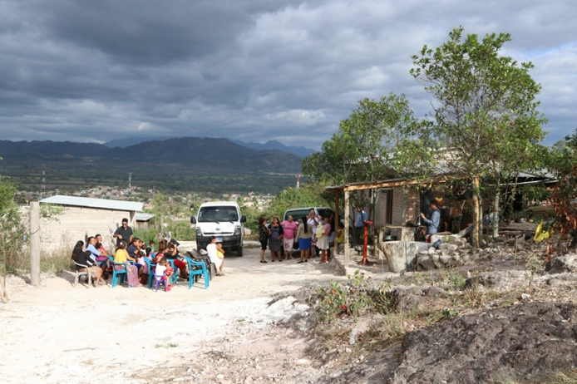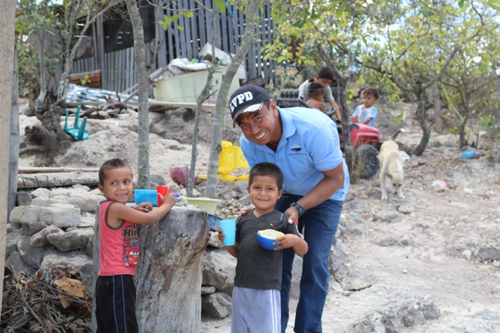

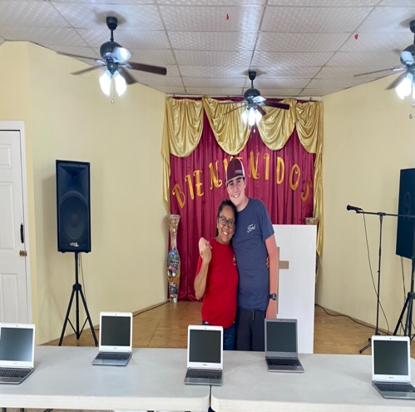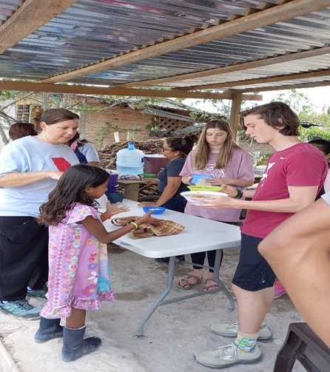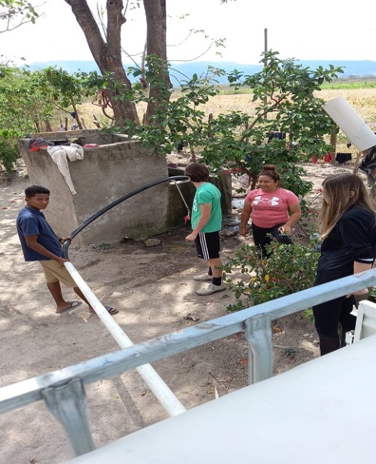

Sewing for Jesus
The students in the sewing ministry under the leadership of Mrs. Ana are growing leaps and bounds with their ability to sew. They have learned how to make shirts, skirts, and this week, they will learn to sew dresses. It is a huge blessing to see the excitement on the faces of the girls and young women as they are learning a trade that will help provide for their families and become a job for them. We are so blessed to have Mrs. Ana and her willingness to use her talent to teach these girls and give them an opportunity to make a difference in their lives.

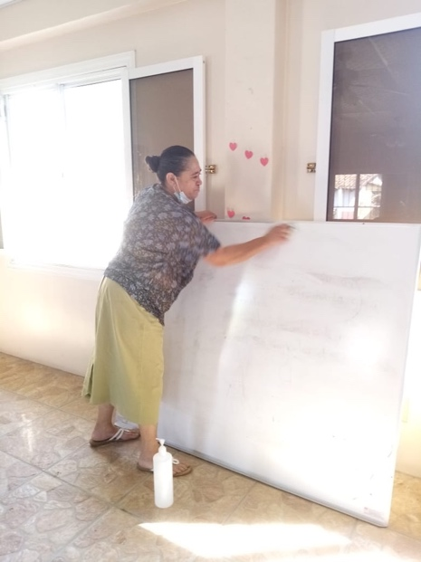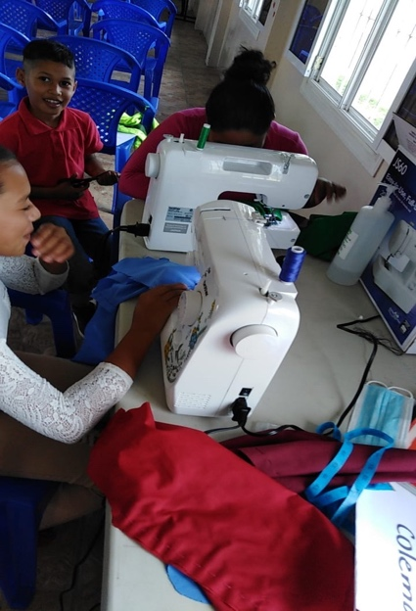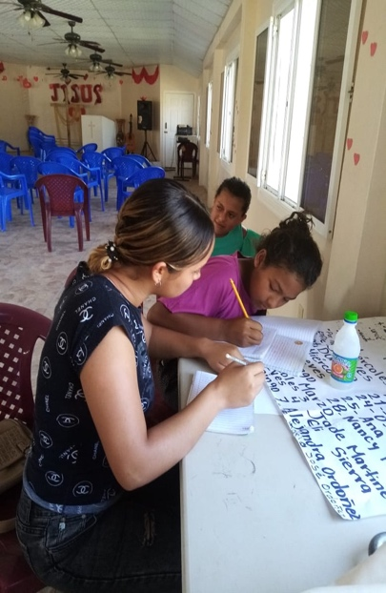

New Desire Stateside Events

New Desire is back on the road and we couldn’t be more excited to be back doing what we love and what God has called us to do! Covid had everything in slow motion as far as going into churches speaking and preaching. We are honored to be back in God’s House sharing the Gospel of Jesus Christ. If you or your church would like to book New Desire for a Women’s Conference, Bible Study, Virtual Bible Study, Revival, or Marriage Retreat, please contact Brenda @ 770-324-0005 or Nicki @ 706-773-1935. Be sure to leave a message. We would love to come and worship with you! Below you will find our upcoming events.

- July 24 – 28 - Women’s Conference and Revival – Neely Memorial Baptist – New Albany, Mississippi
- August 28 – 29 – Women’s Conference and Preaching @ 10:00 cst – Mt. Lebanon Church – Ashville, Ala
- September 25 – Women’s Conference – Higher Ground Baptist Church @ 10:30 cst – Gadsden, Ala
- October 2 – 3 – Women’s Conference and Brenda Sings – Westside Baptist – Newnan, Ga
- October 15-17 – New Desire Marriage Retreat – Gatlinburg, TN - $800 per couple (we still have room for 10 couples) Payments can be made up until day of retreat.
- November 20 – 28 – Honduras Mission Trip (Top and sides for Sunday School Building)

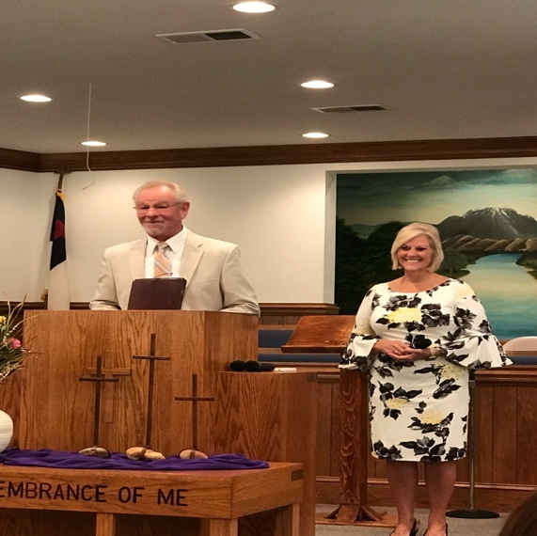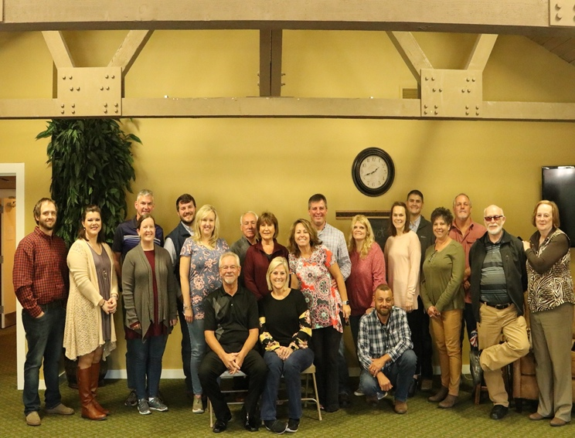

How Can You Help with Our Needs?

Due to a new law in Honduras, large quantities of OTC medicine brought into Honduras causes your items to be taken by the airport for over 24 hours before returning. Due to the amount of time and paperwork it takes to retrieve your items, we are asking for monetary donations and we can purchase some of these items at Pricemart in Tegucigalpa.

More Expensive Needs:
Building up our General Fund to be able to keep the entire mission property and possessions up and running. The general fund is where we put our money for the feeding kitchen, repairs, annual registrations on all vehicles, fuel for feeding kitchen and mission house. The general fund also pays our pastor, mission director, and grounds keeper on a monthly basis. The general fund is our lifeline to keep everything operating. Please pray with us about this account. The church doesn’t take in enough tithes to help with these necessities.

We need:
- Constant Prayer
- Monthly sponsors toward the general fund.
- Sponsors for our Feeding Program each week. It costs $150 per week to feed our elders and school kids in our feeding program and now we are providing for two churches.
- Approximately $6000 to put top and sides on the Sunday School Building
- We are in the process of raising money for a second utility truck. We need this to be able to continue traveling up the mountain and to meet twice the needs of carrying water to fill up pilas.
- We will be providing shoes for Christmas again to the people of both churches of New Desire Honduras. We will provide over 200 pair of shoes for Christmas. Please be in prayer about helping with this need.

Teams Welcome
It is not too late to book your team to come and help us train, feed and minister through bible classes, VBS for children, health teams, visit the community, pass out rice and beans while loving on them through the Word of God, prayer, and listening to their hearts. For more information contact New Desire Christian Ministries at 770-324-0005 or www.newdesire.org or on Facebook. You may also call Nicki Freeman (Missions Administrator) at 706-773-1935 or nickifreeman1973@gmail.com. We appreciate all of your prayers and support. We could not do everything we do without YOU! We Just Love Jesus!

